**EXP 1. Design an automatic night lighting system such the system is only activated when the master control switch is pressed.**

**CIRCUIT DIAGRAM:**

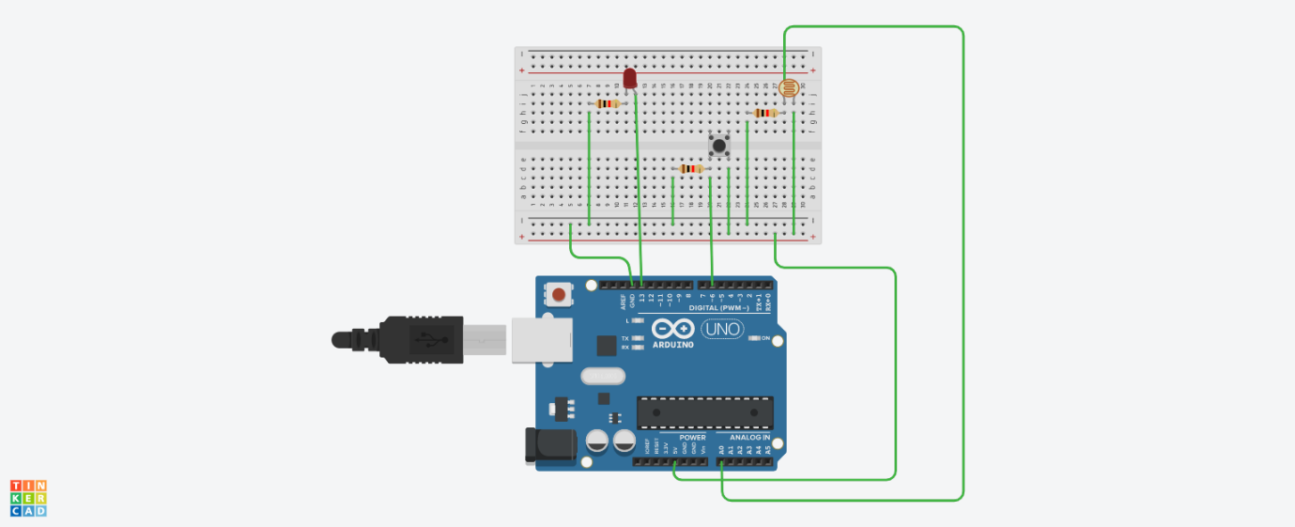

**THEORY:**

**CONCEPT USED:**

In order to detect the intensity of light or darkness, we use a sensor called an LDR (light dependent resistor). The LDR is a special type of resistor that allows higher voltages to pass through it (low resistance) whenever there is a high intensity of light, and passes a low voltage (high resistance) whenever it is dark.

**LEARNING & OBSERVATIONS:**

1. The greater the intensity of light, the greater the corresponding voltage from the LDR will be.
2. One leg of the LDR is connected to VCC (5V) on the Arduino, and the other to the analog pin 0 on the Arduino.
3. The Arduino, with its built-in ADC (analog-to-digital converter), then converts the analog voltage (from 0-5V) into a digital value in the range of (0-1023).
4. The button on the Arduino IDE called “Serial monitor” will open a new window, which prints different values on the screen.

**PROBLEMS & TROUBLESHOOTING:**

Loose connection of cables.

Loose connections of LDR device.

Error in programming or coding.

**PRECAUTIONS:**

While unplugging the USB ,pull the plug nt the cable.

Connectionns should be tight and according to the coding done on audrino software.

Handle the apparatus like AUDRINO BOARD ,LDR and breadboard carefully.

**Learning Outcomes:**

Working and appearence of Audrino.

Working of a photoresistor.

Design and analysis of breadboard alongwith its circuit diagram.